|  |  |  |
| --- | --- | --- |
| **Name : Ayan Ahmed Khan** |  |  |
| **Roll No : 261** |  |  |

**<!DOCTYPE html>**

**<html lang="en">**

**<head>**

**<meta charset="UTF-8" />**

**<title>Employee Registration Form</title>**

**<style>**

**body {**

**font-family: Arial, sans-serif;**

**background-color: #f2f2f2;**

**padding: 20px;**

**}**

**.form-container {**

**background-color: #fff;**

**padding: 30px;**

**border-radius: 8px;**

**max-width: 500px;**

**margin: auto;**

**box-shadow: 0 0 10px rgba(0, 0, 0, 0.1);**

**}**

**.form-group {**

**margin-bottom: 15px;**

**}**

**label {**

**display: block;**

**margin-bottom: 5px;**

**font-weight: bold;**

**}**

**input[type="text"],**

**input[type="email"],**

**textarea {**

**width: 100%;**

**padding: 10px;**

**border: 1px solid #ccc;**

**border-radius: 5px;**

**}**

**textarea {**

**resize: vertical;**

**}**

**.submit-btn {**

**width: 100%;**

**background-color: #4caf50;**

**color: white;**

**padding: 10px;**

**border: none;**

**border-radius: 5px;**

**font-size: 16px;**

**cursor: pointer;**

**}**

**.submit-btn:hover {**

**background-color: #45a049;**

**}**

**.error {**

**color: red;**

**margin-bottom: 10px;**

**text-align: center;**

**}**

**</style>**

**</head>**

**<body>**

**<div class="form-container">**

**<h2>Employee Registration</h2>**

**<form id="employeeForm" onsubmit="return validateForm()">**

**<div class="form-group">**

**<label for="name">Employee Name:</label>**

**<input type="text" id="name" name="name" />**

**</div>**

**<div class="form-group">**

**<label for="email">Email Address:</label>**

**<input type="email" id="email" name="email" />**

**</div>**

**<div class="form-group">**

**<label for="mobile">Mobile Number:</label>**

**<input type="text" id="mobile" name="mobile" />**

**</div>**

**<div class="form-group">**

**<label for="address">Address:</label>**

**<textarea id="address" name="address" rows="3"></textarea>**

**</div>**

**<div class="form-group">**

**<label for="salary">Salary:</label>**

**<input type="text" id="salary" name="salary" />**

**</div>**

**<p id="errorMsg" class="error"></p>**

**<button type="submit" class="submit-btn">Submit</button>**

**</form>**

**</div>**

**<script>**

**function validateForm() {**

**const name = document.getElementById("name").value.trim();**

**const email = document.getElementById("email").value.trim();**

**const mobile = document.getElementById("mobile").value.trim();**

**const address = document.getElementById("address").value.trim();**

**const salary = document.getElementById("salary").value.trim();**

**let errorMsg = "";**

**if (name === "" || !/^[A-Za-z ]+$/.test(name)) {**

**errorMsg = "Please enter a valid name (letters and spaces only).";**

**} else if (!/^\S+@\S+\.\S+$/.test(email)) {**

**errorMsg = "Please enter a valid email address.";**

**} else if (!/^\d{10}$/.test(mobile)) {**

**errorMsg = "Mobile number must be exactly 10 digits.";**

**} else if (address === "") {**

**errorMsg = "Address is required.";**

**} else if (**

**!/^\d+(\.\d{1,2})?$/.test(salary) ||**

**parseFloat(salary) <= 0**

**) {**

**errorMsg = "Please enter a valid positive salary.";**

**}**

**if (errorMsg !== "") {**

**document.getElementById("errorMsg").innerText = errorMsg;**

**return false;**

**}**

**document.getElementById("errorMsg").innerText = "";**

**alert("Employee form submitted successfully!");**

**return true;**

**}**

**</script>**

**</body>**

**</html>**

**OUTPUT :**

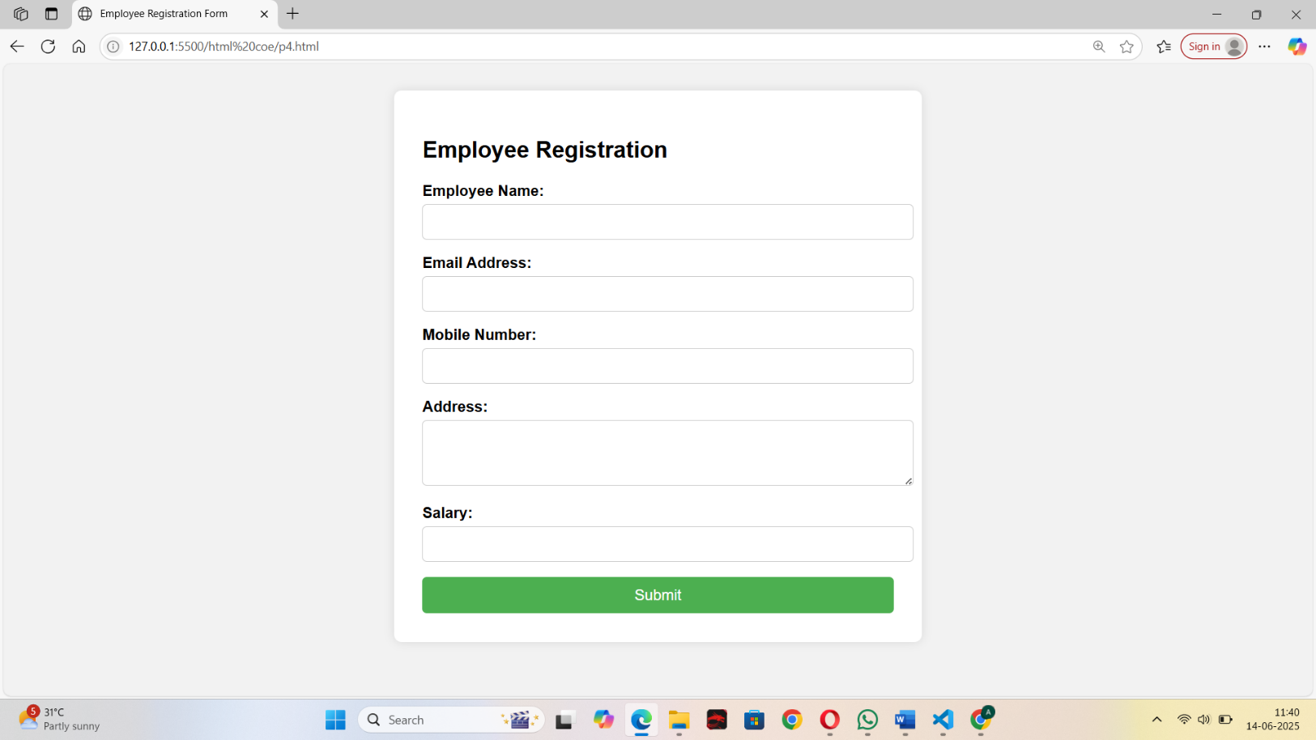

cursor: pointer;

}

.submit-btn:hover { background-color: #45a049;

}

.error { color: